Assignment 16

Steffan Nilsson

- [ ] Sketch a graph having nodes {1,2,3,4,5}, edges {a,b,c,d,e,f} and functions:

- g(a) = (1,2)

- g(b) = (1,3)

- g(c) = (3,4)

- g(d) = (3,4)

- g(e) = (4,5)

- g(f) = (5,5)

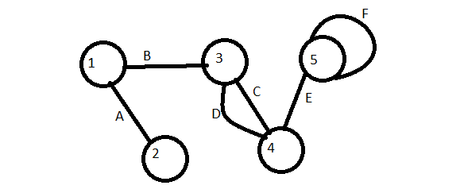

- [ ] Using the graph from question #1, answer the following:

- Find two nodes that are not adjacent

Node 2 and Node 4.

- Find a node adjacent to itself

Node 5.

- Find a loop

Node 5 Edge F is a loop.

- Find two parallel edges

Edges C and D are parallel.

- Find the degree of node 3

Node 3 has a degree of 3.

- Find a path of length 5

2->1->3->4->5->5

- Find a cycle

Node 3 to Node 4 over Edge C then Node 4 to Node 3 over Edge D.

- Is this graph complete?

Yes.

- Is this graph connected?

No, needs edge between 1 and 4, 1 and 5, 2 and 3, 2 and 4, 2 and 5, and between 3 and 5.

- [ ] Draw a connected graph with:

- 1 Vertex



- 2 Vertices

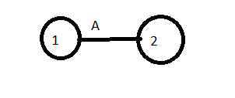

- 3 Vertices

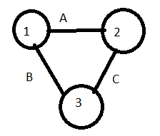

- 4 Vertices

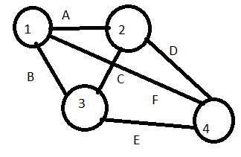

- 5 Vertices

